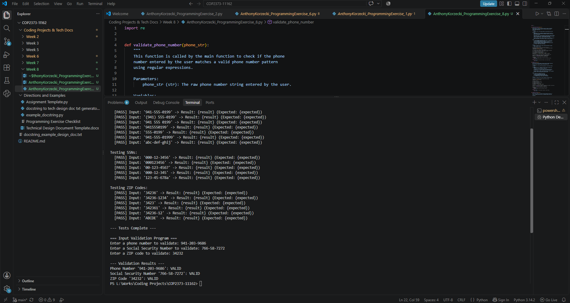

# Technical Design Document: AnthonyKorzecki_ProgrammingExercise_8

# Name: Anthony Korzecki
# Date: October 7th, 2026
# Program Description: This program uses Python regular expressions to validate user-supplied telephone numbers, Social Security Numbers, and US postal ZIP codes against standard structural formats. It executes an automated test suite across diverse test cases before prompting the user for real-time input and reporting whether each entry is valid or invalid.

## Function: main
Main driver function that handles running the test suite, getting
interactive input from the user, and reporting back whether each item
is valid or invalid.

Parameters:
None

Variables:
user_phone (str): Stores the phone number entered by the user.

user_ssn (str): Stores the SSN entered by the user.

user_zip (str): Stores the ZIP code entered by the user.

phone_is_valid (bool): Stores whether the user's phone passed validation.

ssn_is_valid (bool): Stores whether the user's SSN passed validation.

zip_is_valid (bool): Stores whether the user's ZIP passed validation.

Logic:
1. Run run_tests to demonstrate that the regex patterns work.
2. Prompt the user to enter a phone number, SSN, and ZIP code.
3. Pass each input into its respective validation function.
4. Print out whether each item entered was valid or invalid.

Return:
None

## Function: run_tests
This function runs automated test cases through our three validator
functions to prove that both valid and invalid inputs are handled
correctly by the regular expressions.

Parameters:
None

Variables:
phone_tests (list): List of sample phone numbers paired with
their expected boolean outcome.

ssn_tests (list): List of sample SSNs paired with their expected
boolean outcome.

zip_tests (list): List of sample ZIP codes paired with their
expected boolean outcome.

Logic:
1. Build test lists containing valid inputs and invalid edge cases.
2. Loop through phone tests, run
validate_phone_number, and print status.
3. Loop through SSN tests, run validate_ssn, and print status.
4. Loop through ZIP tests, run validate_zip_code, and print status.

Return:
None

## Function: validate_phone_number
This function is called by the main function to check if the phone
number entered by the user matches a valid phone number pattern
using regular expressions.

Parameters:
phone_str (str): The raw phone number string entered by the user.

Variables:
cleaned_phone (str): A temporary variable that holds the user's
input with any accidental outer whitespace removed so extra spaces
don't fail the check.

phone_pattern (str): The regex pattern string used to check the format.
Looks for 10 digits total, allowing optional parentheses on the area
code and optional dashes or spaces between digit groups.

matched (re.Match | None): Stores the result of re.fullmatch. It will
hold a match object if the string is valid, or None if it fails.

Logic:
1. Strip whitespace from phone_str and assign to cleaned_phone.
2. Set up the phone_pattern raw string.
3. Run re.fullmatch to make sure the entire string matches the
pattern with no extra characters hanging off the end.
4. Use an IF statement to check if matched holds an actual match.
5. If True, return True to the caller.
6. If False, return False to the caller.

Return:
Returns a boolean (True or False) indicating whether the phone
number entered is valid.

## Function: validate_ssn
This function verifies whether the Social Security Number entered by
the user follows standard 9-digit SSN formatting rules.

Parameters:
ssn_str (str): The raw SSN string passed in from the user input.

Variables:
cleaned_ssn (str): A temporary string to store the input with
leading and trailing whitespace stripped off.

ssn_pattern (str): The regex pattern string requiring 3 digits,
an optional dash, 2 digits, an optional dash, and 4 digits.

matched (re.Match | None): Holds the match object from re.fullmatch
to check if the string passed the pattern check.

Logic:
1. Clean outer whitespace from ssn_str.
2. Build the ssn_pattern regex string.
3. Run re.fullmatch against the cleaned input.
4. If matched exists, return True to the caller.
5. If matched is None, return False to the caller.

Return:
Returns a boolean (True or False) showing if the SSN is valid.

## Function: validate_zip_code
This function checks if the postal ZIP code entered by the user is
either a standard 5-digit code or an extended 9-digit ZIP+4 code.

Parameters:
zip_str (str): The raw ZIP code string entered by the user.

Variables:
cleaned_zip (str): Stores the sanitized input string without outer
spaces.

zip_pattern (str): The regex pattern that matches 5 digits, plus
an optional group containing a dash and 4 extra digits.

matched (re.Match | None): Holds the result of re.fullmatch to tell
us if the postal code matched the pattern.

Logic:
1. Strip whitespace from zip_str and store in cleaned_zip.
2. Set up zip_pattern to look for 5 digits and optional +4 group.
3. Evaluate the cleaned string with re.fullmatch.
4. Return True if a match was found.
5. Return False if no match was found.

Return:
Returns a boolean (True or False) indicating if the ZIP is valid.

#Link to your repository: https://github.com/akorzecki/COP2373-11162

